**Personal progress report no.2**

**Assembly**

I put together the saddle with the bed. Later, I set some limitations of the travel distance of the saddle, tail stock.

Tran and I measured the travel limitations of the cross-slide, which is -40mm and 60mm, in the x-axis.

**Y**

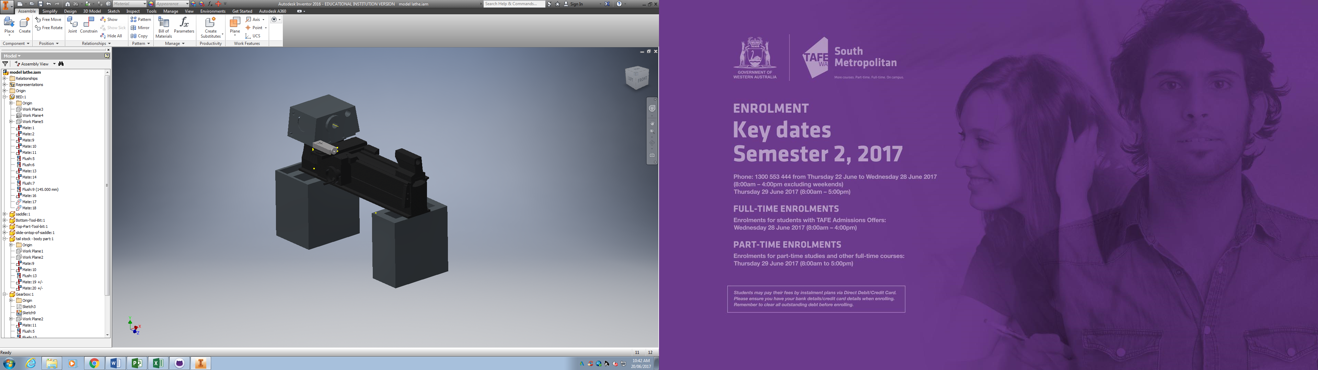

**-X**

**Z**

**X**

Therefore, we could place and calculate the length of the ball screw of the x-axis, which is 530mm. I could fit a rolled ball screws of R series from NSK (RNFTL 1405A2.5S) of shat diameter 14 and lead 5.

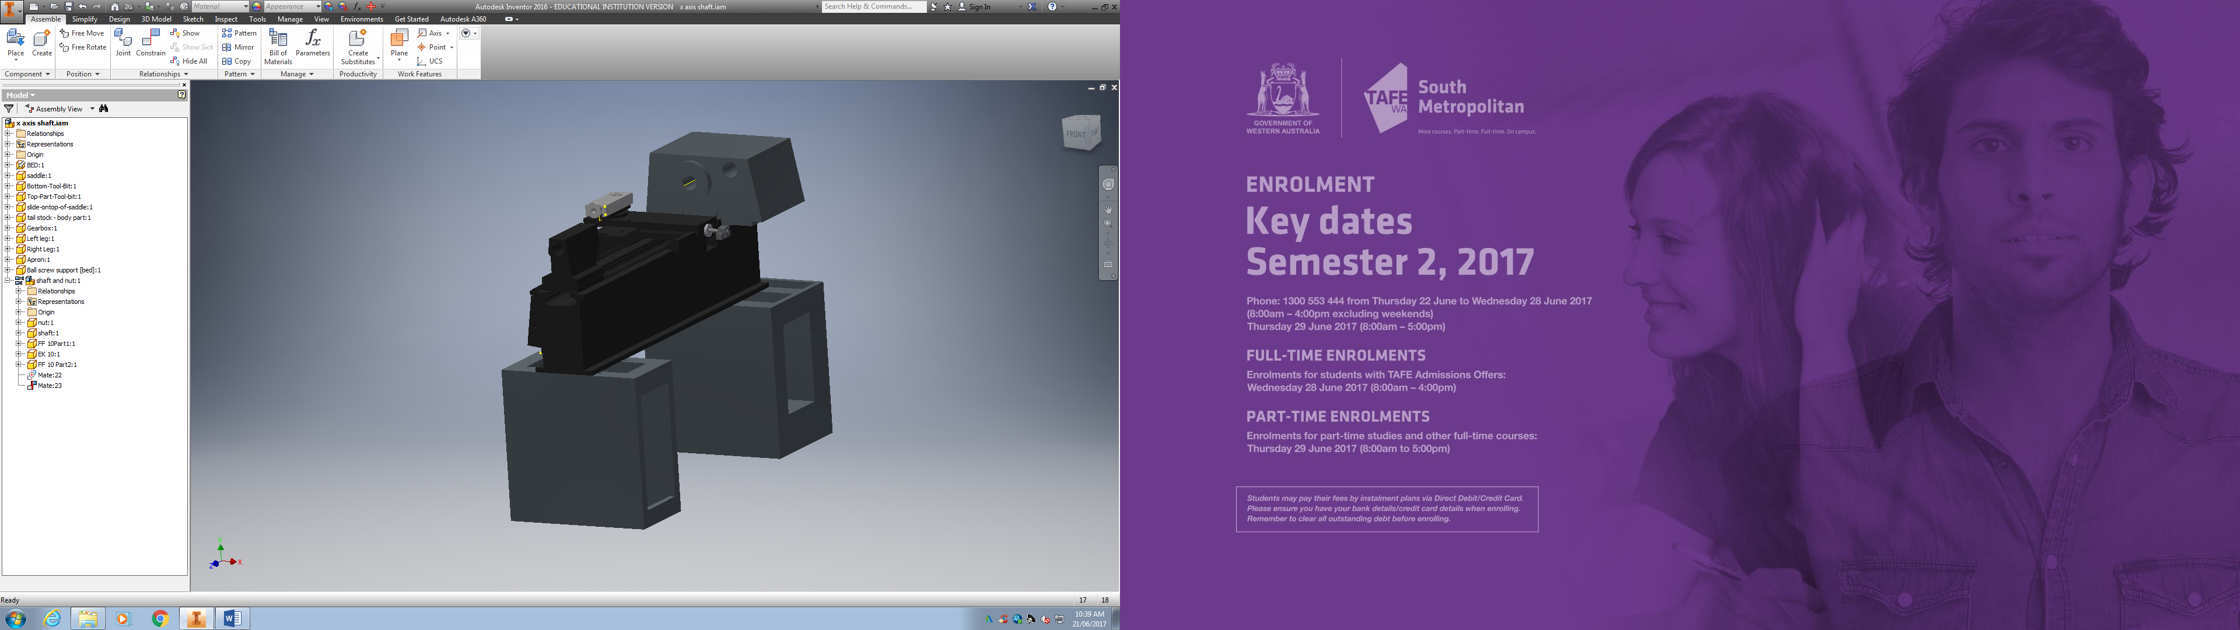

Rectangular support (THK)

Nut specifications from RNFTL 1405A2.5S

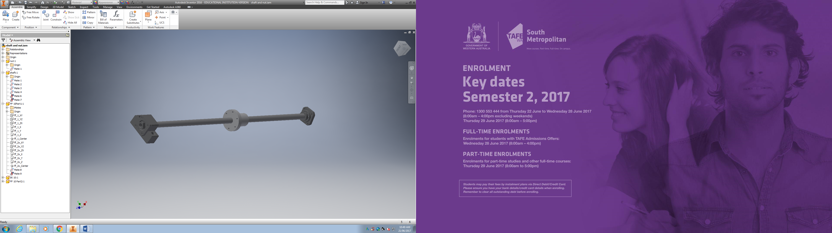

Round support (THK)

The supports (both ends) on the model are the ones from the THK Company which I generated from their software for a shaft diameter 14.

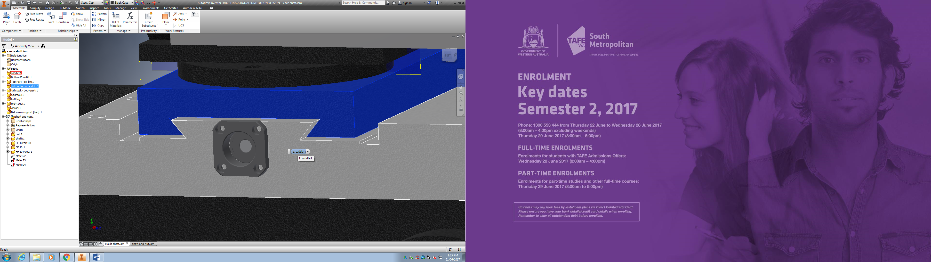

**0.952mm**

A distance of 0.952mm needs to be cut from the rectangular support so the it will not touch the cross-slide when this slides.

**Update of the Gantt chart/ list of activities**

I created a new working time calendar that has the holiday days, for instance ANZAC day and the 2 weeks off of term 1 to term 2. In addition, I added non-working days from Wednesday to Monday.

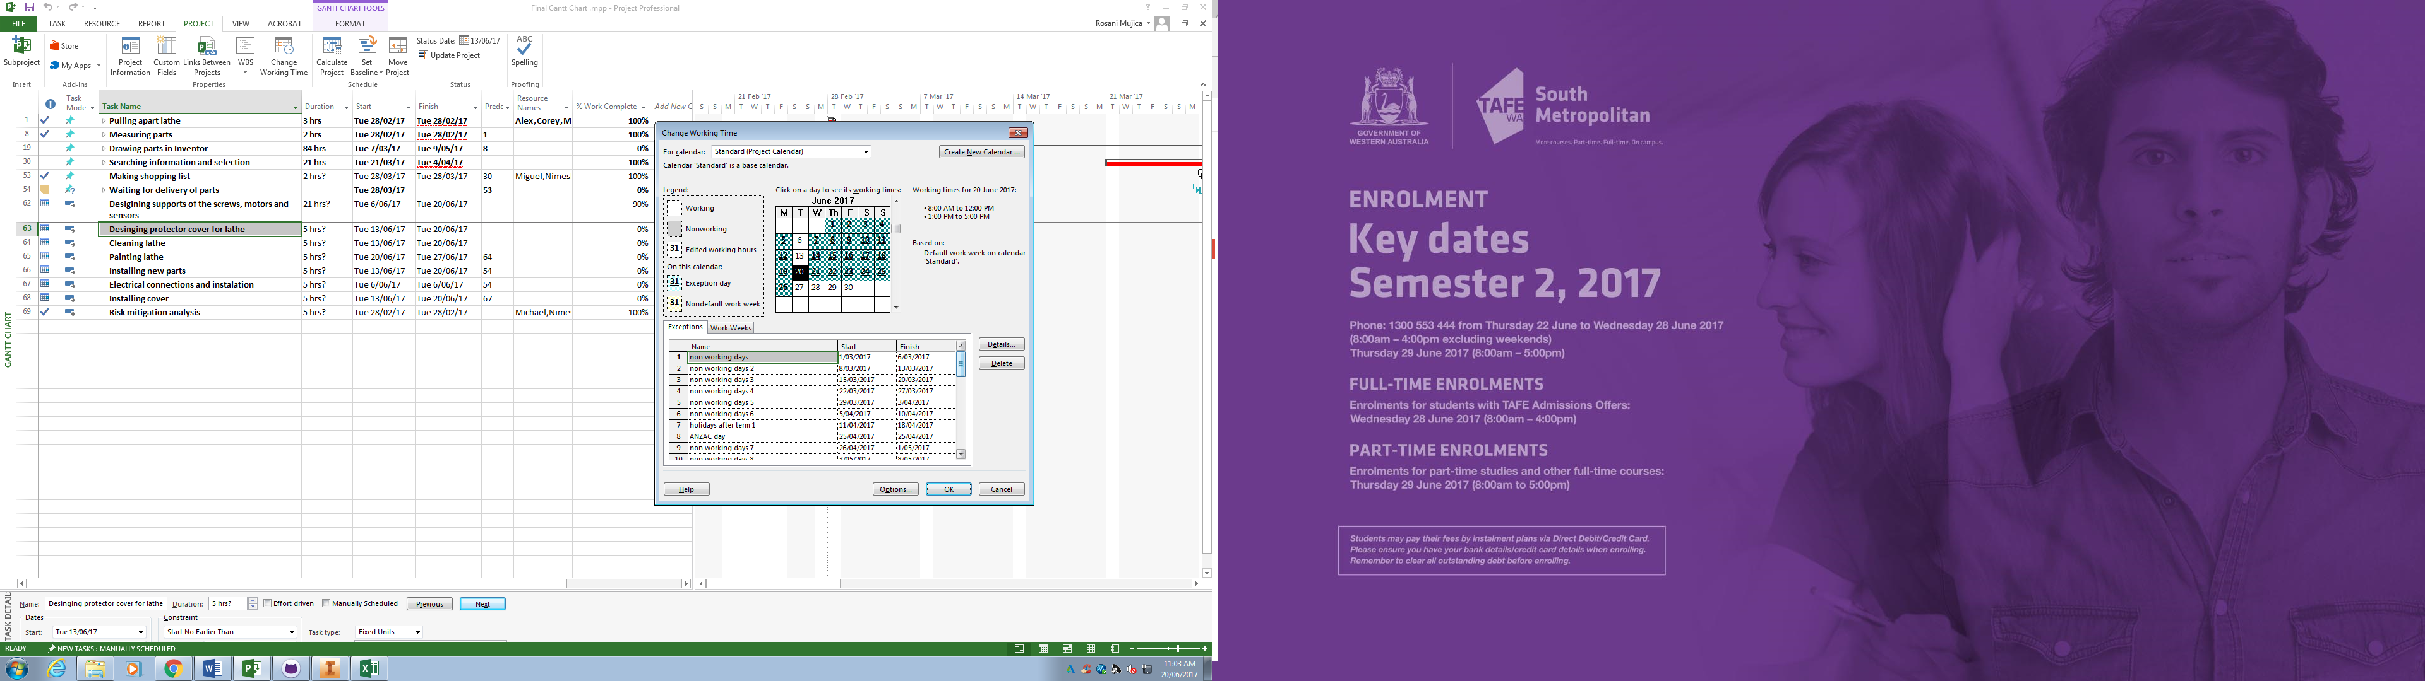

**Activities**



I assigned the real dates that we have taken to finish the work. But, for example, comparing the time that we should have taken to draw the parts in inventor was 2 workings days (10 hours), in contrast with this new Gantt chart we took 10 workings days (50 hours).

**Risk mitigation analysis**

I listed all the possible hazards of the mechanical part and went through all the standards for mechanical and electrical parts. However, one member of each team participated in the development of the part “Identify and evaluate existing risk controls” and “Further Risk Treatments”.

|  |  |  |  |  |  |  |  |  |
| --- | --- | --- | --- | --- | --- | --- | --- | --- |
| **Identify Hazards and subsequent Risks** | **Analyse Risks & Evaluate Risks** | | | **Identify and evaluate existing risk controls** | | | **Further Risk Treatments** | **Standards** |
|
| **Hazards/Issues/Risks** | **Consequence** | **Likelihood** | **Risk level** | **What we are doing now to manage this risk**. | **Effectiveness of our strategies** | **New risk level** | **Further action needed** |
| **Opportunities for improvement** |
| **MECHANICAL** | | | | | | | |  |
| Flying objects such as the chuck key left in chuck | 4 | E | H | Barrier between the workpiece and operator (Protective cover) | Reduces the risk of flying object | L | Voice control | AS 4024.1601-2006 4.6.1(a) , 6.1.3 AS4024.1-1996 (15.3.2.4) |
| Cutting tool injury when cleaning,  filing or polishing (machine off) | 1 | D | L | Risk sign. Authorization | Let people be aware of possible  risk | L | Training | AS 4024.1601-2006 6.3.5, .4.2. 10.2 |
| Metal chips and swarf coming loose | 3 | A | X | Barrier between the workpiece and operator (Protective cover) and the usage of PPE | Reduces the possibility of chips flying out of the machine | L | Voice control | AS 4024.1601-2006 4.6.1(a) |
| Rotating machine parts- entanglement | 5 | E | H | Machine stops when door is open (Mechanical sensor) | Prevent people from getting caught | L | Preventive action | AS 4024.1601-2006 4.6.1(a) AS 4024.1-1996 (15.3.2.3) |
| Closing movements of parts under  power can result finger trapping | 4 | C | X | Machine stops when door is open (Mechanical sensor) | Prevent people from getting caught | L |  | AS 4024.1601-2006 4.6.1(a) AS 4024.1801-2006 |
| Work pieces can very hot | 2 | D | L | Monitoring coolant flow | Assure coolant is running at all time | L | PPE |  |
| Contact with cutting fluids, oil and grease can irritate skin | 1 | B | M | PPE | Prevent skin from contacting fluids | L | PPE | AS 4024.1601-2006 6.1.4 AS 4024.1-1996 (15.4) |
| Swarf can jam the machine or be  ejected if allowed | 1 | E | L | Power protection | Neither motor nor swarf jam have contact with the operator | L | - |  |
| Eye injury | 4 | D | H | Barrier between the workpiece and operator (Protective cover) | Reduces the risk of flying object | L | PPE | AS 4024.1601-2006 4.6.1(a) |
| **ELECTRICAL** | | | | | | | |  |
| Electrocution | 5 | E | H | Check all cables before turning on lathe | Reduce the likelihood of Electrocution | M | Install RCA | AS/NZS 3000:2007 |
| Electric shock | 4 | E | H | Check all cables before turning on lathe | Reduce the likelihood of Electric shock | M | Install RCA | AS/NZS 3000:2007 appendix L |
| Soldering Iron Burns | 2 | C | M | Check the heat from the lathe and training | Lower the risk of damage to person | L | Use Common sense |  |
| Proximity Switch Failure | 3 | D | M | Test switches with lathe off | Assure the function of the switches and replacement of broken switches | L | Recheck switches periodically | AS/NZS 3000:2007 (7.2.2.2) |
| Safety Switches Failure | 3 | D | M | Test switches with lathe off | Assure the function of the switches and replacement of broken switches | L | Recheck switches periodically | AS 4024.1.-1996 (15.3.2.8) |
| Catastrophic Lathe Failure | 4 | E | H | Add an safety stop button | Allows the operator to stop the lathe before catastrophic injury happens | M | PPE | AS 4024.1.-1996 (15.3.2.8) |

**Update resource sheet**

|  |  |  |  |  |  |  |  |  |  |  |
| --- | --- | --- | --- | --- | --- | --- | --- | --- | --- | --- |
| Resource Name | Type | Material Label | Initials | Group | Max. Units | Std. Rate | Ovt. Rate | Cost/Use | Accrue At | Base Calendar |
| Corey | Work |  | C | Control | 100% | $0.00/hr | $0.00/hr | $0.00 | Prorated | Standard |
| Nimesh | Work |  | N | Electrical | 100% | $0.00/hr | $0.00/hr | $0.00 | Prorated | Standard |
| Rosani | Work |  | R | Mechanical | 100% | $0.00/hr | $0.00/hr | $0.00 | Prorated | Standard |
| **Sean** | **Work** |  | **S** | **Mechanical** | **100%** | **$0.00/hr** | **$0.00/hr** | **$0.00** | **Prorated** | **Standard** |
| Alex | Work |  | A | Mechanical | 100% | $0.00/hr | $0.00/hr | $0.00 | Prorated | Standard |
| **Miguel** | **Work** |  | **M** | **Control** | **100%** | **$0.00/hr** | **$0.00/hr** | **$0.00** | **Prorated** | **Standard** |
| Sandeep | Work |  | S | electrical | 100% | $0.00/hr | $0.00/hr | $0.00 | Prorated | Standard |
| Michael | Work |  | M | electrical | 100% | $0.00/hr | $0.00/hr | $0.00 | Prorated | Standard |
| Tran | Work |  | T | control | 100% | $0.00/hr | $0.00/hr | $0.00 | Prorated | Standard |
| Tom | Work |  | T | Machinist | 100% | $0.00/hr | $0.00/hr | $0.00 | Prorated | Standard |
| Ross | Work |  | R | General Manager | 100% | $0.00/hr | $0.00/hr | $0.00 | Prorated | Standard |
| Gavin | Work |  | G | Electrician | 100% | $0.00/hr | $0.00/hr | $0.00 | Prorated | Standard |
| Daniel | Work |  | D | Programmer | 100% | $0.00/hr | $0.00/hr | $0.00 | Prorated | Standard |
| Tool box | Material |  | T |  |  | $0.00 |  | $0.00 | Prorated |  |
| Sand blasting | Work |  |  |  | 100% | $0.00/hr | $0.00/hr | $0.00 | Prorated | Standard |
| ball screw | Material |  | b |  |  | $0.00 |  | $0.00 | Prorated |  |
| servo motor | Material |  | s |  |  | $0.00 |  | $0.00 | Prorated |  |
| sensors | Material |  | s |  |  | $0.00 |  | $0.00 | Prorated |  |
| Brake for spindle | Material |  | B |  |  | $0.00 |  | $0.00 | Prorated |  |
| VSD encoder input variable speed that can take an input | Work |  | V |  | 100% | $0.00/hr | $0.00/hr | $0.00 | Prorated | Standard |
| Drivers | Work |  | D |  | 100% | $0.00/hr | $0.00/hr | $0.00 | Prorated | Standard |
| Servo motor | Material |  | S |  |  | $660.00 |  | $0.00 | Prorated |  |
| Servo motor driver | Material |  | S |  |  | $550.00 |  | $0.00 | Prorated |  |
| Ball screw nut - Z axis | Material |  | B |  |  | $0.00 |  | $0.00 | Prorated |  |
| Ball screw shaft - Z axis | Material |  | B |  |  | $0.00 |  | $0.00 | Prorated |  |
| Ball screw nut - X axis | Material |  | B |  |  | $0.00 |  | $0.00 | Prorated |  |
| Ball Screw shaft - X axis | Material |  | B |  |  | $0.00 |  | $0.00 | Prorated |  |
| Coolant pump | Material |  | C |  |  | $319.00 |  | $0.00 | Prorated |  |
| Coolant | Material |  | C |  |  | $192.50 |  | $0.00 | Prorated |  |
| Zincalume | Material |  | Z |  |  | $0.00 |  | $0.00 | Prorated |  |
| Glass | Material |  | G |  |  | $0.00 |  | $0.00 | Prorated |  |
| Belt encoder | Material |  | B |  |  | $100.00 |  | $0.00 | Prorated |  |
| VSD | Material |  | V |  |  | $878.00 |  | $0.00 | Prorated |  |
| Computer | Material |  | C |  |  | $430.00 |  | $0.00 | Prorated |  |
| Limit switches | Material |  | L |  |  | $103.22 |  | $0.00 | Prorated |  |
| Inductor sensor | Material |  | I |  |  | $80.37 |  | $0.00 | Prorated |  |
| Read switch | Material |  | R |  |  | $27.50 |  | $0.00 | Prorated |  |
| Float level switch | Material |  | F |  |  | $19.29 |  | $0.00 | Prorated |  |
| Linix CNC Controler 2 | Material |  | L |  |  | $1,675.85 |  | $0.00 | Prorated |  |
| break out blocks | Material |  | b |  |  | $66.00 |  | $0.00 | Prorated |  |